Assignment 1.3
Robert Breutzmann's CSD340 GitHub
First Run with 3 errors:
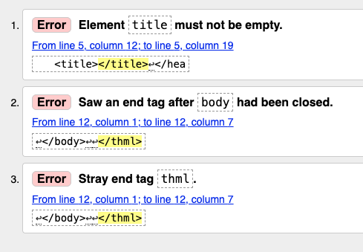

Second Run with the Errors Fixed:
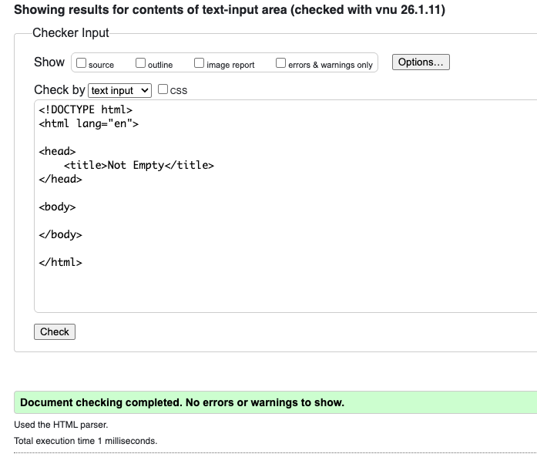

Final Run with the updated code showing no errors:

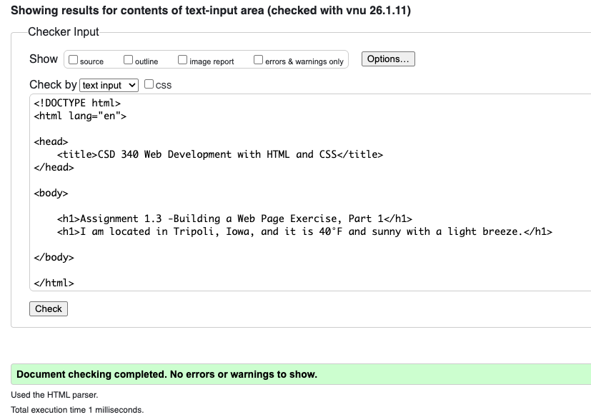

Screenshot of HTML document displayed using Crome

